**Carpal tunnel**

**Initial Assessment**

|  |  |  |
| --- | --- | --- |
| **Presenting Symptom/Chief Complaint** | | |
| Painful obstruction syndrome at the both wrist area, tiredness, lack of muscle power, tingling and weaknes**s** at the middle fingers area. Cold fingers. | | |
| **Main Signs and Symptoms** | | |
| Patient has difficulties with working on the computer, also has disturbances with sleep due to pain at the wrist area. | | |
| **Other Signs and Symptoms** | | |
| Feeling cold and tired at the end of the day. Prone to constipation. | | |
| **TCM Diagnosis and Treatment (identified TCM disease, TCM differentiation of syndromes)** | | |
| Painful obstruction syndrome at the wrists due to cold and dampness invasion QI deficiency of the spleen. | | |
| **Treatment Principles and Strategies** | | |
| Remove the dampness. Expel cold, stimulate Qi of the spleen and nourish the blood. | | |
| **Treatment Plan (Modalities; acupuncture, herbal, dietary, manual therapies), frequency and duration** | | |
| Acupuncture + Moxibustion with sedation of local points for 10-15 min following with tonification of the distal points involving tonification of Qi and nourishing the blood 1 hour every second day. | | |
| **Any other Advice Given to Patients** | | |
| Acupuncture LI 4 (bilaterally), Lu7, Lu9,H7, H6 (bilaterally), TW5 with combination of TW8 – stimulate the Qi raising in all 3 Jang channels, St36, LI11, Du 20, Du 17, Du 12 to raise the Qi of the main system in the body. Normalize the sleep and nourish the blood. LI 10 acupressure both sidesto release the muscle tension at the area and wrist, LI 3, LI 2, LI 1 to move the blood and resolve the dampness at the area. UB 60, UB 62. St 36, SP6 bilaterally. | | |
| **Practitioner:**  **L.Georgiev** | **Date:** | **Signature:** |

**Carpal tunnel**

**Daily Charting____________________________________Patient Name:_________________________**

**Date:________________**

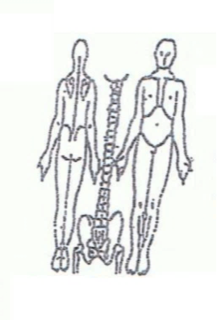 **Working Diagnosis:** Painful obstruction syndrome at the both wrist area due to cold and dampness Qi deficiency **Sp** and stagnation of the Qi at the area.

S: Patient is complaining with both wrist pain that worsening at the end of the day and interrupting the sleep. Constant cold feeling at the hand and low power of muscle.

O:

Treatment (P) Acupuncture 1 hour **.** Recommend wrist support.

(A)

**Date:________________**

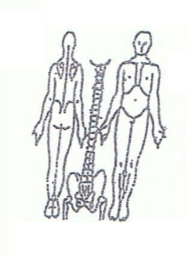**Working Diagnosis:**

S: Patient still have week wrist and **hangs grasp**, painful movement of fingers at the end of the day. Need to stop a lots of time during the day with pain at the wrist area and low muscle power.

O:

Treatment (P) Acupuncture + Moxa - 1 hour as per plan.

(A)

**Date:________________**

**Working Diagnosis:**

S: Patient is sleeping better, nervousness at the work. power of the muscle at the hand area. Fingers are **warm**.

O:

Treatment (P) Acupuncture + Moxibustion for 1 hour with preferable tonification.

(A)

**Date:________________**

**Working Diagnosis:**

S: Patient is feeling much better. No sleep disturbance. Fresh and energized in the morning. Good mood. Can work all day without painand tiredness.

O:

Treatment (P) Acupuncture with warm needle 1 hour. Start the wrist exercises.

(A)